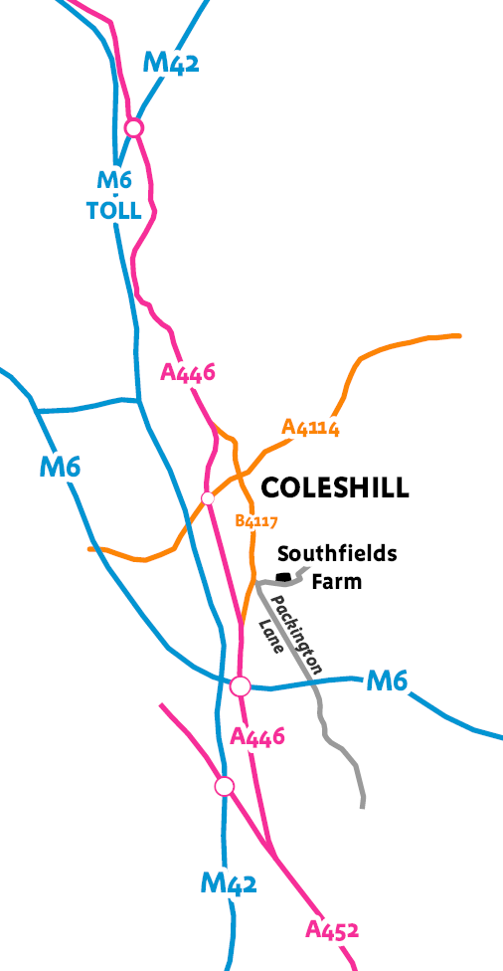
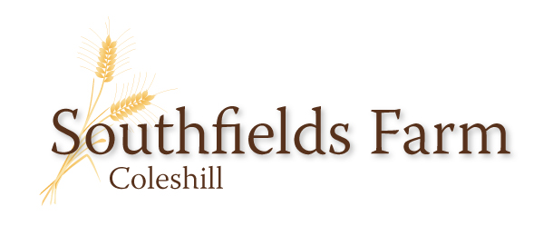

Farm-based education and therapy

Southfields Farm, Packington Lane, Coleshill, Birmingham Warwickshire B46 3EJ
The Farm is very easy to find, at the entrance to Packington Lane on the edge of Coleshill.
There is ample space to park and turn coaches.

Contact :
John Plumb 07855 450639
john@southfieldsfarm.uk
Richard Windridge 07806 651688
richard@southfieldsfarm.uk
FACE member
(Farming and Countryside Education)
LEAF member
(Linking Environment And Farming)
DEFRA approved farming methods
CEVAS accredited
(Countryside Educational Visits Accreditation Scheme)
NFU membership
(National Farmers Union)
CRB checked

Our aims:
To share a love of and respect for the countryside

To promote a caring approach to the environment

To educate young people about food and farming

To foster a desire to learn about God’s creation
August 2017

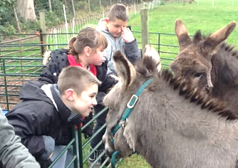
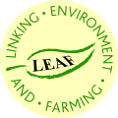
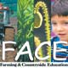
Welcoming special children to a special place
The story so far:
Farming in Britain has been through dramatic changes. In one lifetime it has had its own industrial and technical revolution with remarkable increases in productivity, followed by an economic downturn due to global competition and supermarket domination.
Southfields Farm has responded to the changes. Like so many we were forced out of milk production. We now produce crops as efficiently as possible with contract machinery and labour, whilst retaining hedges, wildlife margins, ponds and natural land features. A friendly flock of sheep and some store cattle keep the river meadow and historic permanent grazing in useful production.
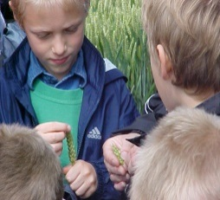
We are part of the ‘Higher Level’ Stewardship Scheme which provides advice and finance for projects which enhance wildlife habitats on the farm. There is also some limited support for school visits. With the support of Natural England, an old milking shed was converted into a classroom / meeting room. As a bonus, the old milk bulk tank room was transformed into a toilet and washroom area.
The farm has hosted ‘Open Farm Sunday’ events since 2007. On a Sunday afternoon in June, we have welcomed many different people onto the farm in all sorts of weather. We believe that the farm is a special place to connect people, animals, green space, wild-life and the general outdoor environment.
The Paddock:
In recent years the local special needs school and the farm have planned and developed a facility called the ‘paddock’. Its close proximity to the school means that a class can either walk or have a trailer ride to visit each day. The paddock has been designed so that there is easy access to the animal enclosures and then continuing into the growing area where there are raised beds and a poly-tunnel for class activities.
The activities that we offer for both therapeutic and educational sessions include:
- Tractor and trailer rides to tour the farm
- Exploring habitats
- Field to fork
- Meeting the large farm animals
- Interact with the smaller animals
- Propagation, planting in the poly-tunnel
- Activities with soil and seed
- Facilities to sit and have drinks / snacks
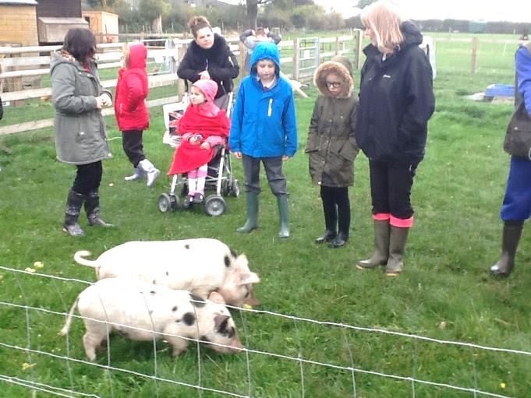

What we offer:
The therapeutic sessions are always planned with easy access in mind. We can arrange for a visit to the whole farm when conditions are dry and favourable.
Currently we charge £150 for a 2 hour session, or £200 for the whole day, normally 10 – 2pm. .

Health & Safety:
Risk assessment procedures have been carried out and we will send you a comprehensive risk assessment beforehand and then give proper directions on the day of the visit.
What we need to know from our visitors:
We strongly recommend a brief pre-visit to ascertain how we can best contribute to any current projects. We will give advice on suitable clothing and footwear. The classroom is often available for a class to eat their packed lunch, so please ask about including a lunch break at the farm as well.

